CAS PY 106

InClass Note 31

1. Two sources of waves can interfere with each other
2. 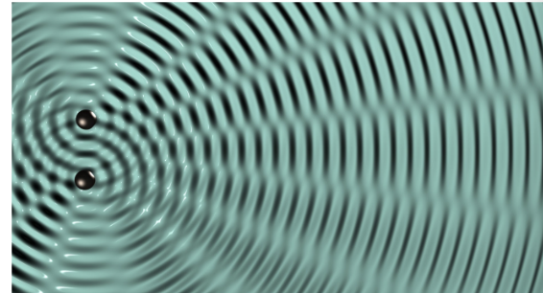
3. Pattern from a single source
4. 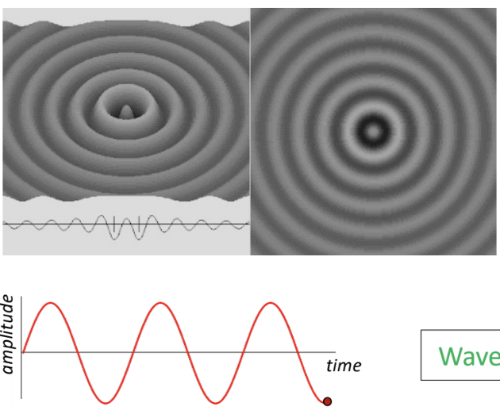
5. Single slit = point source of circular waves
6. 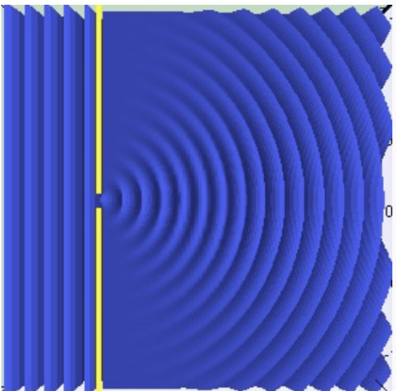
7. Double slit interference
8. 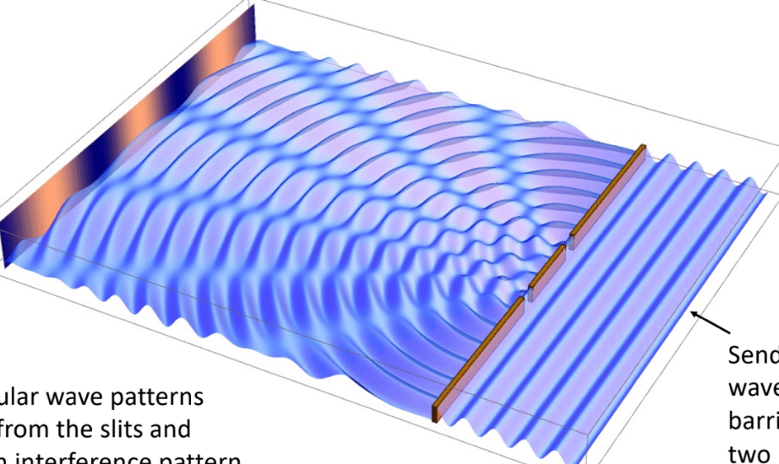
9. Two circular wave patterns emerge from the slits and create an interference pattern
10. Consider two slits, each producing a light wave, in phase
11. 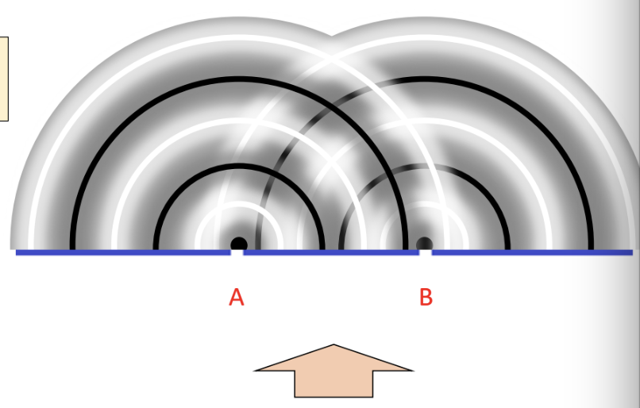
12. Whether light or sound, solid lines are the crests here
13. 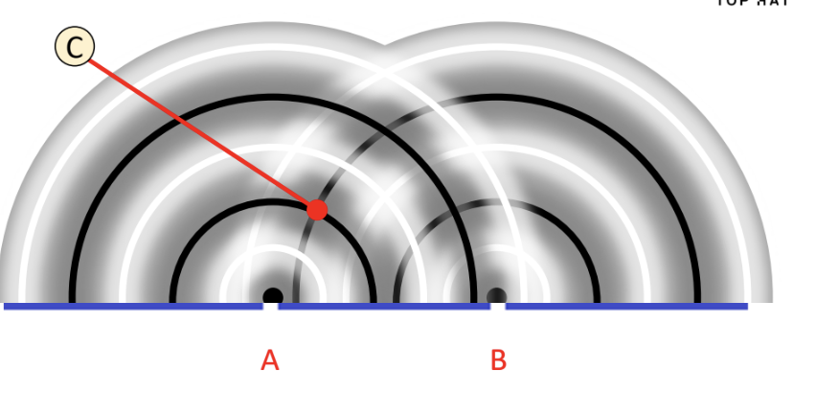
14. At point C, we will always have constructive interference

* Distance A to C is 1 wavelength
* Distance B to C is 2 wavelengths
* Path length difference delta L = 2-1 = 1 wavelength

1. 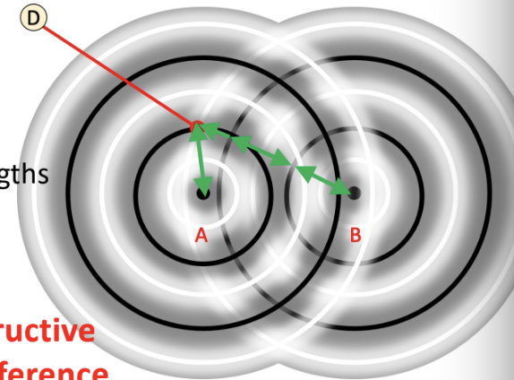
2. At point D, we will always have destructive interference

* Distance A to D is 1 wavelength
* Distance B to D is 2.5 wavelengths
* Path length difference delta L = 2.5-1 = 1.5 wavelengths

1. Path length difference, delta L (in phase)
2. Constructive interference if path length difference is integer number of wavelengths: L = m \* lambda where m is an integer
3. Destructive interference if path length difference is half-integer number of wavelengths: L = (m + ½) \* lambda, where m is an integer
4. If the two sources are 180 degrees out of phase, then our equations each shift by lambda/2

* Constructive: m \* lambda + lambda/2 = (m+ ½) \* lambda
* Destructive: (m + ½) \* lambda + lambda/2 = m \* lambda